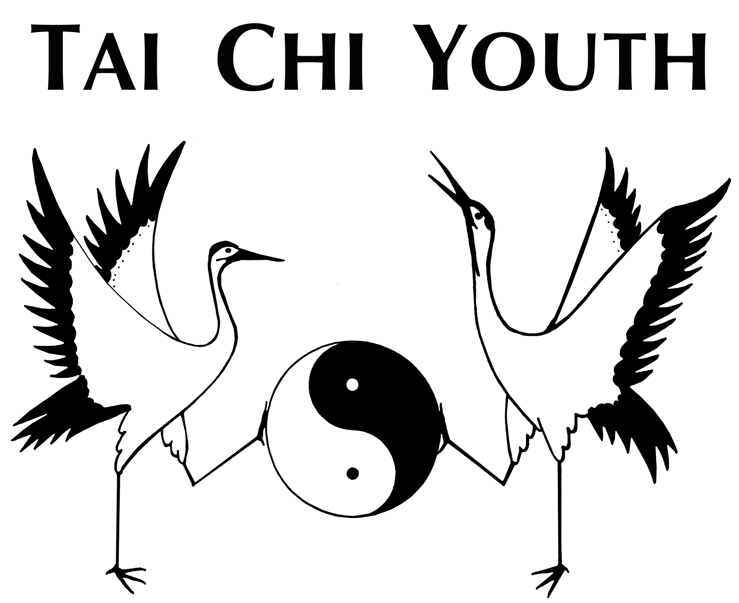
Updated: July 12, 2015
Tai Chi Youth
TCY Board of Directors
Standard Operating Procedures
re: ELECTION OF OFFICERS

Standard procedure for election of elected officials of TCY Board of Directors. In an emergency situation in which an IMMEDIATE REPLACEMENT is NECESSARY, a special meeting may be scheduled if unanimously agreed by TCY Board of Directors.

1. Commitment Letter #1
a. Cover Letter: applicant expresses interest – provides contact information
b. Commitment Letter #1: establishes sincere interest (no obligation)
c. applicant Resume: determines qualifications
2. Interview #1
a. TCY Officer Application Form: checklist of items for applicant study
b. Tai Chi class Release Form: required of all students of TCY
c. Tai Chi class Correspondence Sheet: instructor attendance form
d. Tai Chi class Student Application: Member Fee + Tuition fee: month/semester/private
e. applicant reviews TCY Interview Notebook: overview and understanding of Tai Chi Youth
f. interview questions and discussion: determine TCY job choices of applicant
g. Decision to continue interview process: mutual enthusiasm
3. Interview #2
a. Commitment Letter #2: evaluate possible TCY involvement, abilities, resources
b. interview questions and discussion: TCY current job choice
c. Submit “Interviewer Summary” to TCY Nomination committee
4. TCY Nomination committee
a. Board Buddie = Review applicant: evaluate, background check, reference checks
b. “TCY Nomination Committee Summary #1:” submit to TCY President (1st approval)
c. Final interview: resolve issues, establish confidence, verify enrollments in class
d. “TCY Nomination Committee Summary #2:” submit to TCY President (2nd approval)
5. TCY Board of Directors
a. TCY Stated Meeting: Board Buddie submit “TCY Nomination Committee Summary #2”
b. applicant election vote schedule: 4 week minimum at next monthly Regular Stated Meeting
c. TCY Stated Meeting Election Vote: at least 20 day notice to all TCY Board of Directors
i. Nomination by TCY Board Member = TCY Board Buddie (see chart)
ii. Discussion of applicant, then call for vote (or request more information and suspend vote)
iii. 2/3 majority vote required (unless appointed by TCY Patriarch)

